Tree Report – David Thornber Arboricultural Consultant.
--------------------------------------------------------------------------------------------------------------
Prepared for Kevin Newsham. Clark to Rufford Parish Council

Location. Rufford Recreation Ground, Land adjacent to

Report date 3rd June 2026.
Weather. Good visibility between showers.

Terms of reference.
A tree inspection was undertaken following the resident of 181 Liverpool Road, Joan Quinian contacting the Parish Council.

Trees situated in the Recreation grounds overhanging the boundary where inspected for condition, structural safety and nuisance encroachment.

The following list of works should be undertaken in the interest of safety and to abate a nuisance.

T1 Oak at the entrance of 171 Liverpool Rd. Minor clearance required over driveway and to clear telephone cables.

T2 Horse Chestnut (large mature tree in good condition. Previously crown raised) Crown lift 6 to 7 metres.

T3 Ash, dying less 50% leaf cover. Fell. Or reduce to retain trunk for habitat conservation values.

T4 a mature standing dead tree (recorded in previous surveys). Potential to start breaking-up.
Remove as a matter of priority at the earliest opportunity.

T5 Elm, substantial low growth, branches close to and on roof of the garage. Remove it to provide several metres clearance.

A1 2 x Sycamores 1 x Oak Low over lawn area. To contain nuisance crown, lift 5 to 6 metres

In addition to the above works, in order to allow for access to maintain the wooden fence by the owner, clear any vegetation to provide a 1 to 2 metre space along the whole fence line.

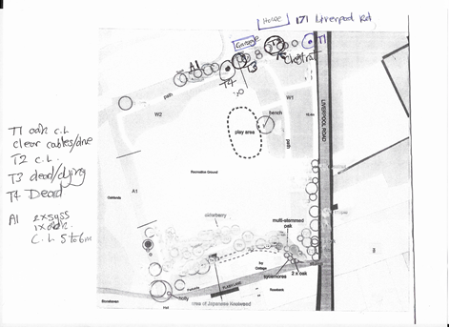

-------------------------------------------------------------------------------------------------------------------
A common law duty of care and regarding safety, which includes a common duty of care towards neighboring properties.

Also, the Occupiers Liability Acts 1957 and1984 require owners to maintain land to an acceptable level of safety.

Publications referenced.
The Body Language of Trees. A handbook for failure Analysis.
Claus Matthheck and Helge Breloer.

Limitations of the Survey/Report
All tree surveys are undertaken from ground level and trees are not climbed
as part of the inspection. No internal examination of the trees was undertaken.
At no time has the issue of subsidence been considered as part of this report.
Comments on the condition and safety of any tree relate to the condition of
the tree at the time of inspection. This appraisal is limited to a 2-year
inspection period, if more frequent tree specific inspection is required it will be
stated in the recommendations. Trees are living growing things that cannot be
guaranteed safe.
Unless otherwise specified, no checks have been conducted in respect of
statutory controls that may apply, e.g. Tree Preservation Orders, Conservation
Areas or planning conditions. In addition, prior to undertaking any tree works,
it is necessary to ensure due diligence is followed in respect of protected
species and habitats, and identifying any permissions required.
Third Party Disclaimer
Any disclosure of this report to a third party is subject to this disclaimer. The
report was prepared by David Thornber at the instruction of Kevin Newsham, and
for the use by, the clients named within the report. This report does not in any
way constitute advice to any third party who is able to access it by any means.
David Thornber Arboricultural Consultant, fully excludes lawfully permitted, all liability
whatsoever, for any loss or damage arising from reliance on the content of
this report.

David Thornber, Arboricultural Consultant, is insured for public liability and professional indemnity.

David Thornber
Arboricultural Consultant.
NDH. Tech Cert (Arbo.A). ILAM Cert. LCGI

